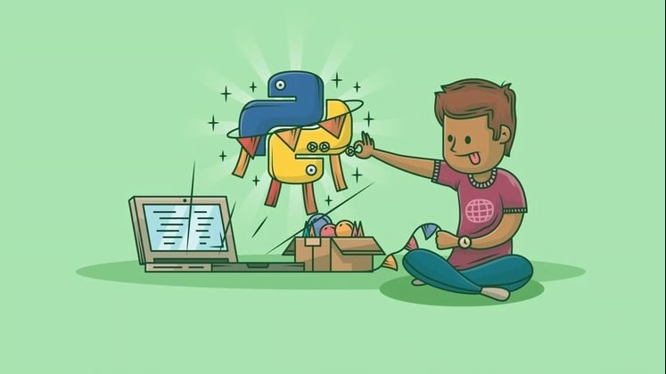

Python And Flask Framework Complete Course For Beginners  
  
Beginner to Expert Python And Flask.Start from the basics and go all the way to creating your own applications and games

Contraseña: cursosparatodospormega

https://app.degoo.com/share/y4LQuj4w7KMNSr?_branch_match_id=857312931582036399